What does Service Dogs of America offer?
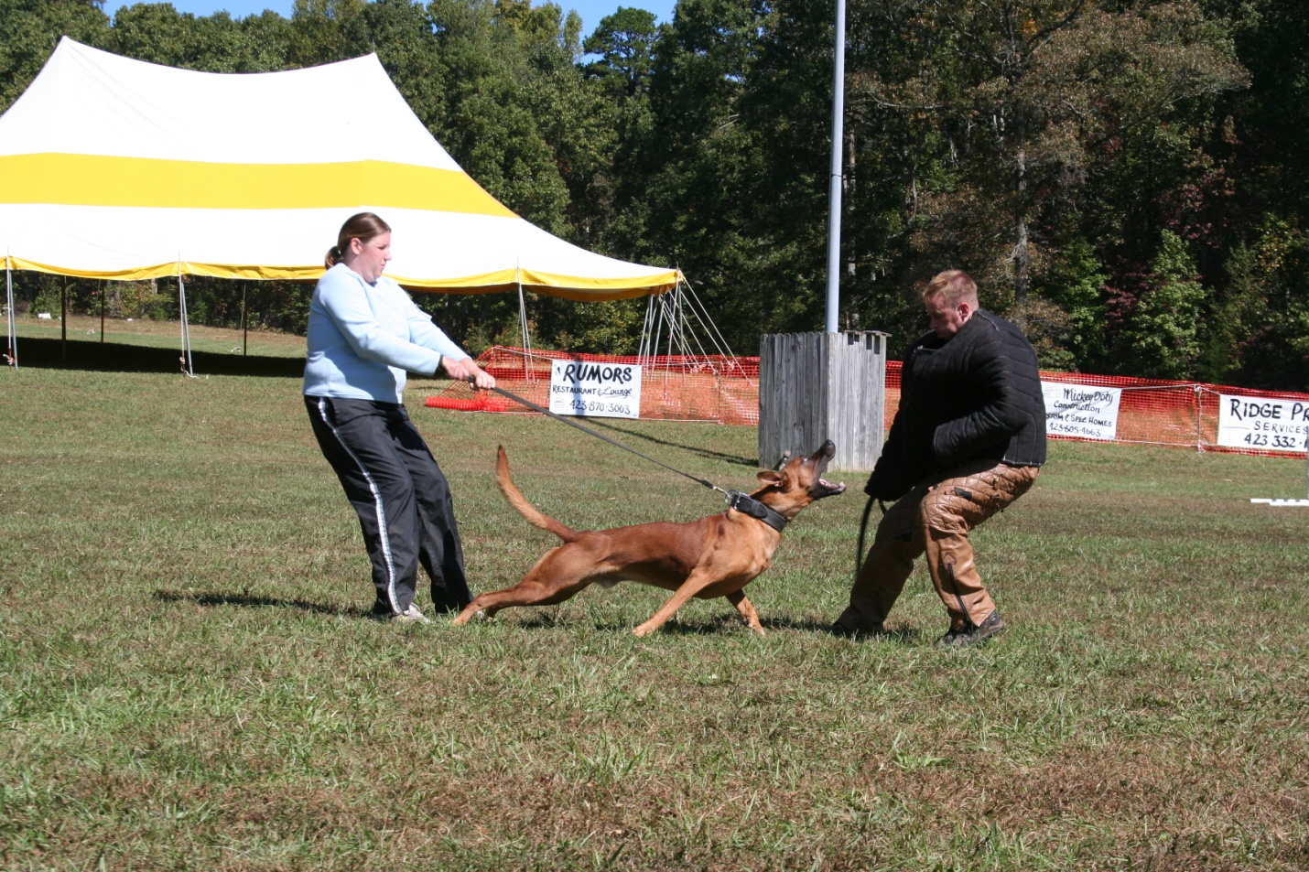

(Helper Threat During the Jump Out Attack of SDA P1)
- SDA offers training titles and events that are specifically designed to meet the needs, interest and life styles of most American dog owners.
- SDA is as an organization that directly benefits dog trainers. SDA offers training titles and events that create business for dog trainers; in addition these titles create demand for establishing dog clubs from clients.
- All of SDA training titles are designed with a specific purpose to meet the objectives of the title. SDA training titles were designed for the four main categories of dog training needs concerning obedience and protection which include the following: a. Family Dog b. Police Related c. Competitive Training d. Breed Evaluation
- SDA welcomes all breeds and all dog loving responsible people. SDA training titles can be performed by a wide variety of dogs!
- SDA offers the first online American registry that is totally dedicated to the needs of true working dogs.
- SDA founders and other leaders are all dedicated dog owners who want to build a special organization that promotes the improvement of working dogs and their programs. Each main leader of this program has made personal sacrifice in time and financially. All of SDA founders and main leaders would be classified as givers and not takers when it concerns the betterment of dogs and this organization.
- SDA offers dog owners here in the US the opportunity to make a significant contribution to the future of working dogs in the United States and even the world.
- SDA offers the best training titles in the world. All titles were created by selecting the best training exercises from established dog training organizations and by creating new exercises to meet a specific training demand.
- SDA offers dog trainers options and choices to select the type of training that a dog owner needs or has an interest.
- SDA designed all of its training titles to be practical, beneficial and as real as possible in meeting the needs of the dog owner.
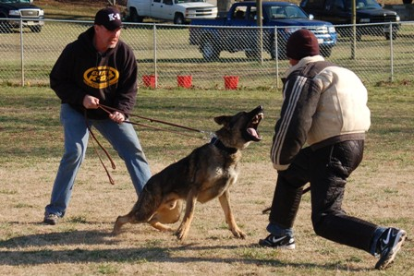
The dog views the helper’s threat as real!
Highlights of the SDA Program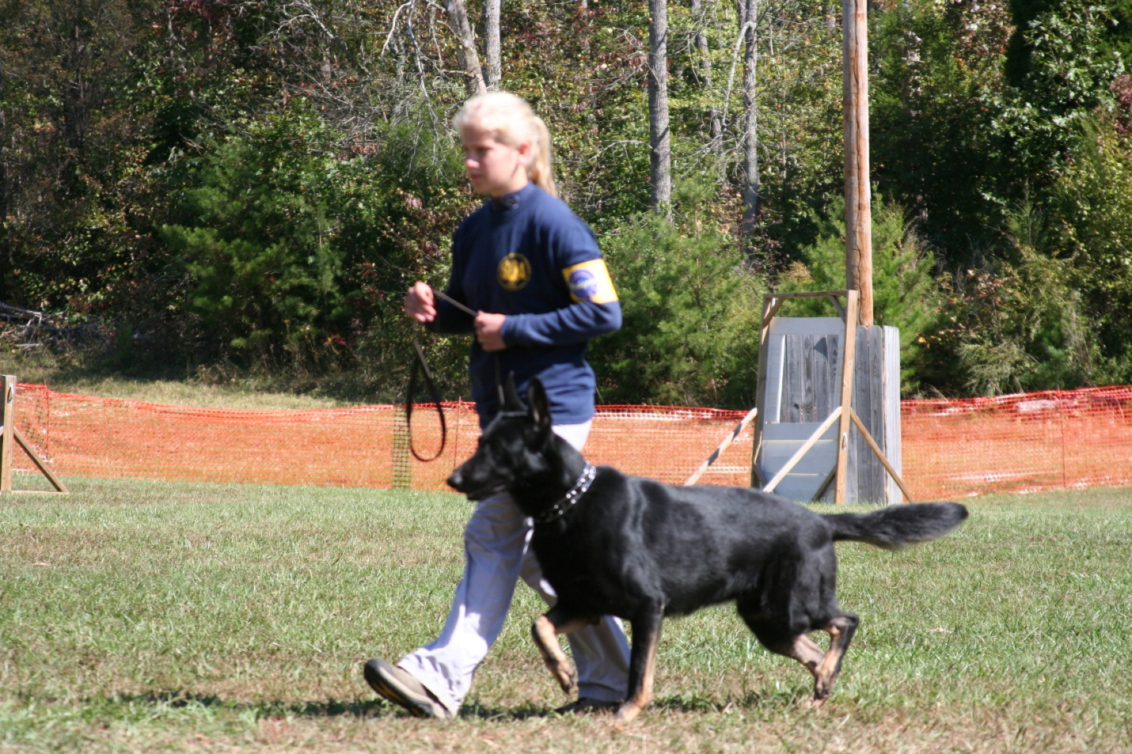
(Heeling prior to the Jump out Attack of SDA P1)

- SDA offers one the best introductory obedience titles in the country for introducing people to dog training and for meeting the obedience needs of a family companion dog. This title is excellent for creating business for dog trainers. SDA’s more advanced obedience titles are excellent for meeting all other needs and interest for obedience training.
- SDA offers the two best Protection titles in the country for meeting the needs of a family protection dog and for introducing people to protection training. The Protection Alert & Protection 1 are totally designed around the obedience and protection needs and demands of a family or personal protection dog; both of these titles will create business for dog trainers and will help in establishing dog clubs.
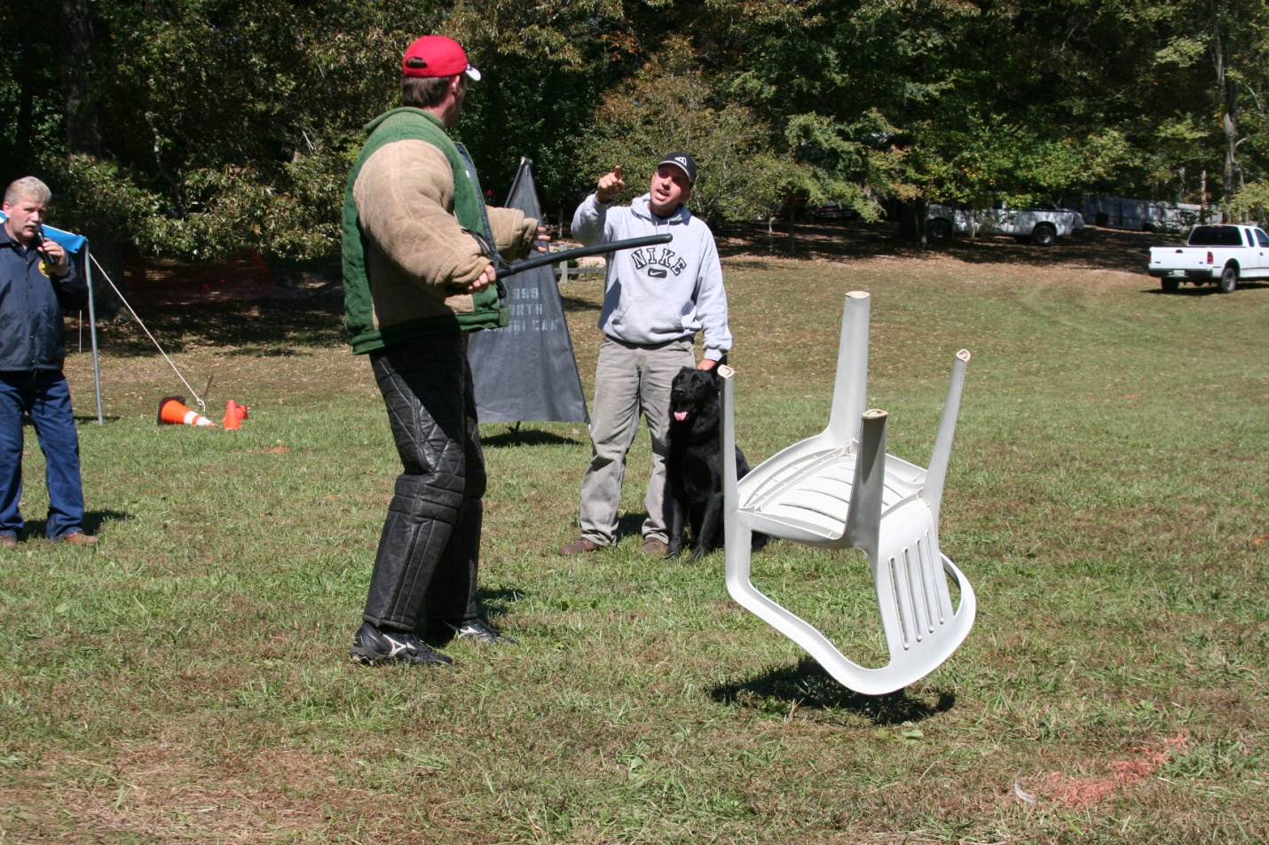
(Argument Drill during a SDA PD1)

- SDA offers training titles specifically designed to meet the needs and demands for police dogs or for police dog type training. The PD1 is excellent for identifying police dog prospects, The PD2 is an excellent title for a credible certification for a police dog and PD3 police dog title that exceeds all current standards required for police dogs. In addition, all of the above police related titles are excellent for providing information about a dog that is being considered for breeding.
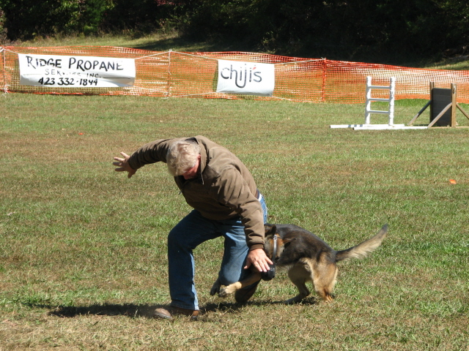
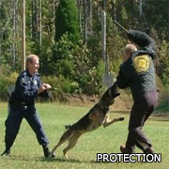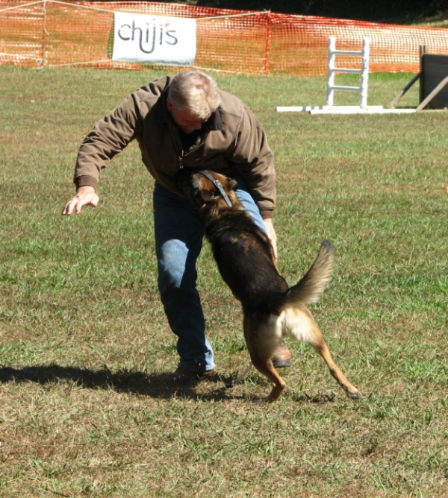

- SDA offers two advanced training titles that are very similar to Schutzhund; we at SDA would describe these titles to be more in line with the original concepts of Schutzhund. The SDA P2 & P3 can be performed with the helper wearing a sleeve or wearing a bite suit; modifications have been made to make the titles universal. When the P2 or P3 are being performed with helper wearing a sleeve suit the titles are called a P2S and P3S.
- Another major highlight of the SDA program is its helper or decoy work; the helper work for this program is both traditional and unique; the major difference is the role of the helper to become viewed as an adversary to the dog and not just the dog’s gripping partner. The following picture demonstrates how the helper provides a very strong threat through body language as the dog is approached prior to gripping in SDA PD1; the goal of the helper is to be adversarial as possible! SDA helpers are evaluated on their threat level prior and during the grip. The more intimidating a helper can be the better! Helpers who earn 90 or more points out of hundred are considered upper level helpers.

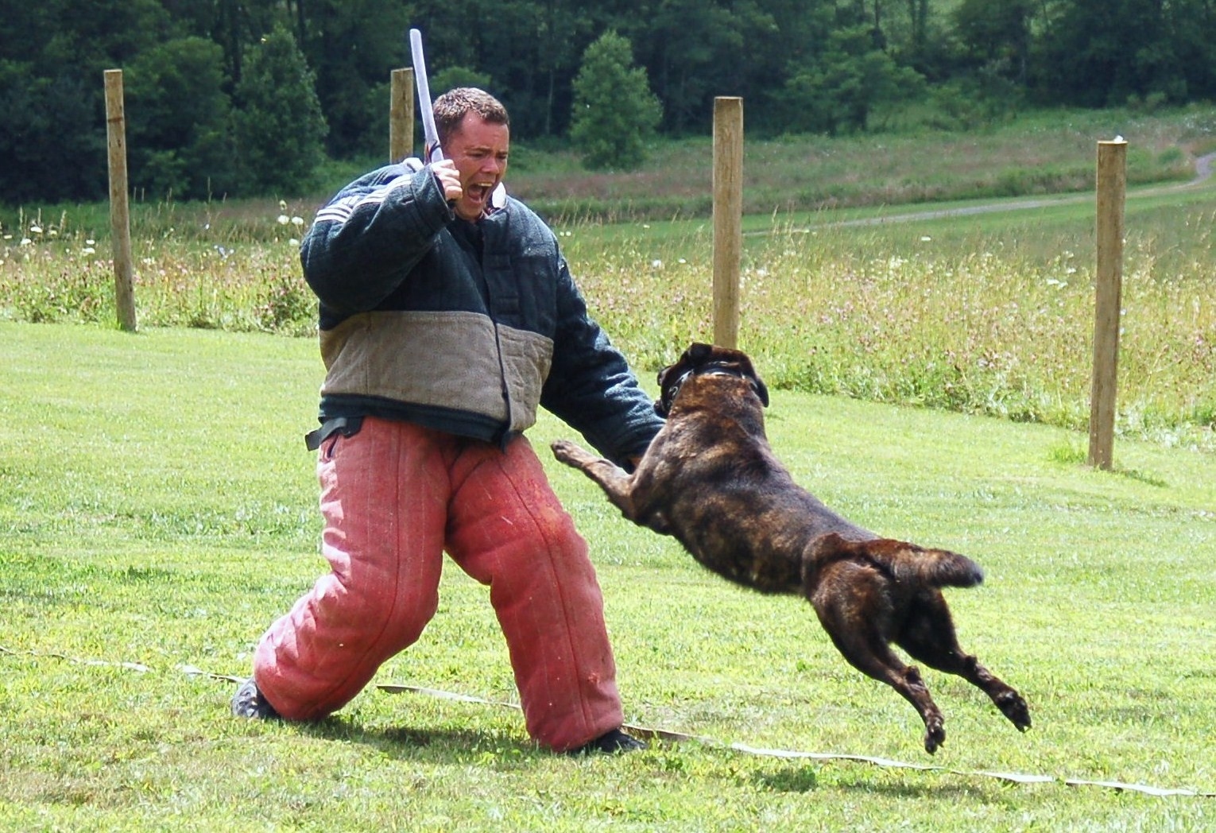
Helpers are also rated on their traditional helper skills, check out the requirements for SDA Helpers.
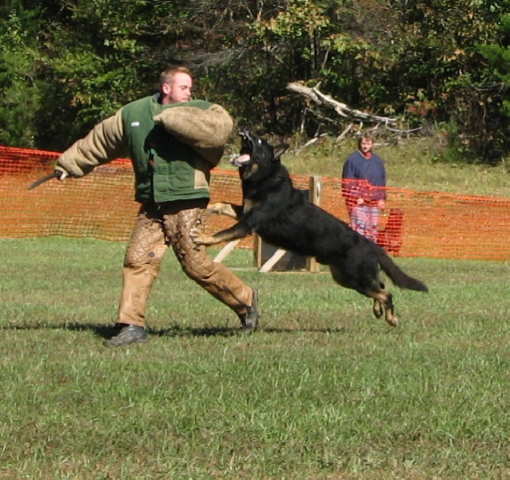
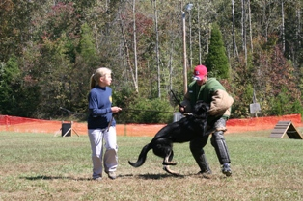
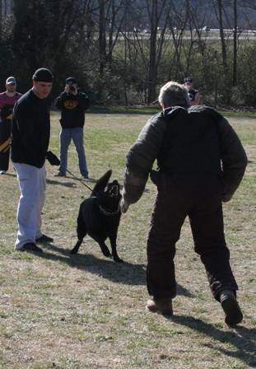

- Another unique aspect of the helper work is the options that are available, suit dogs can grip upper or lower and some grips can be given on the inter arm versus a forearm presentation. Our goal is to make our program appealing and available to a wide a variety of dog trainers without losing any integrity of the test for the title.
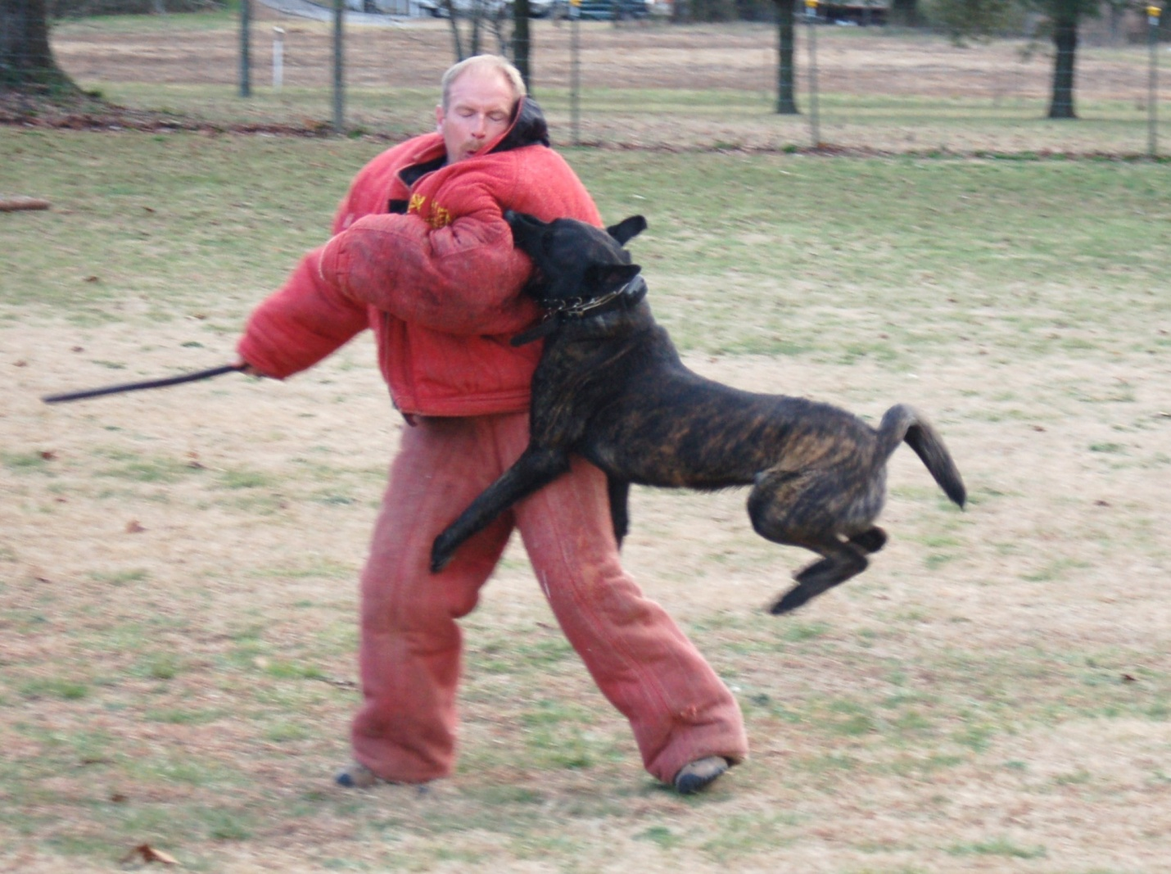

- SDA training titles were designed to be fun to train, entertaining to watch and as safe as possible for dogs, decoys and handlers. We at SDA want all of participants to leave our events in the same manner as they came concerning any injuries.
- Last, SDA offers individual dog owners the opportunity to have a major impact on dog training here in the United States; each person has the opportunity to make this program their own and join the SDA team. We at SDA are looking for leaders and individuals that believe in the program. If you want to be part of this program please contact anyone of our main members for information. Check out our website for all types of information concerning SDA. http://www. ServiceDogofAmerica.com

